1. I chose a prior of (θh, θw)=(50,50).

Make $μ-2σ=0$, where we can have a 95% confidence interval within 2 variance, we know $σ1=σ2=25.$

Assuming the correlation between husband and wife age is 0.5, then $σ12=σ21=25*25*0.5=312.5$

Thus we have

2. The prior predictive distribution under such prior assumptions is as following

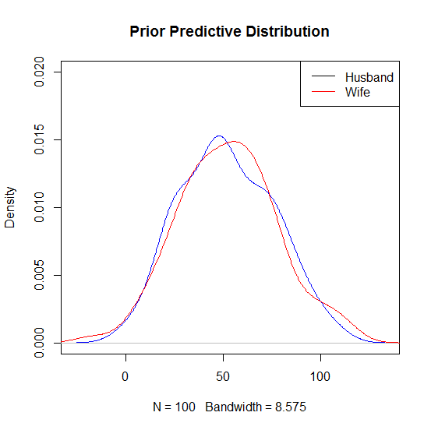

Figure 1: Prior Predictive Distribution Test Plot 1, under prior assumption stated in Q1

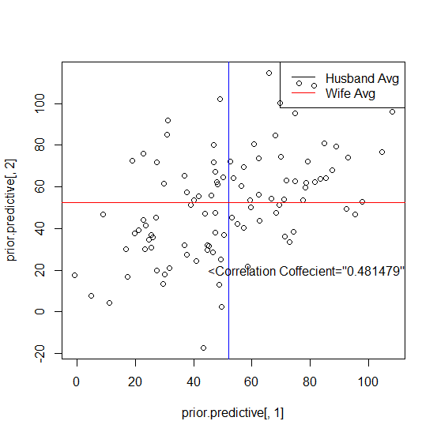

Figure 2: Scatter Plot of θh, θw in Prior Predictive Distribution, example 1

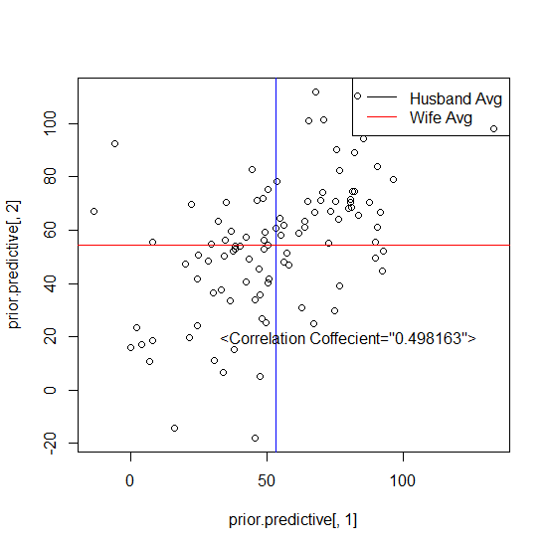

Figure 3: Scatter Plot of θh, θw in Prior Predictive Distribution, example 2

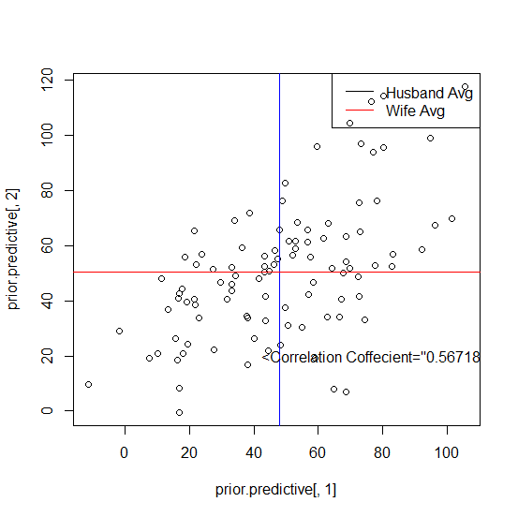

Figure 4: Scatter Plot of θh, θw in Prior Predictive Distribution, example 3

From the above three figures, we can see, our prior If your prior predictive datasets does generally conform to your beliefs of the parameters.

3. Following the method in Hoff book page 112-113, which is also stated in Lab lectures, we can do the Gibbs sampling, upon a prior stated in question 1.

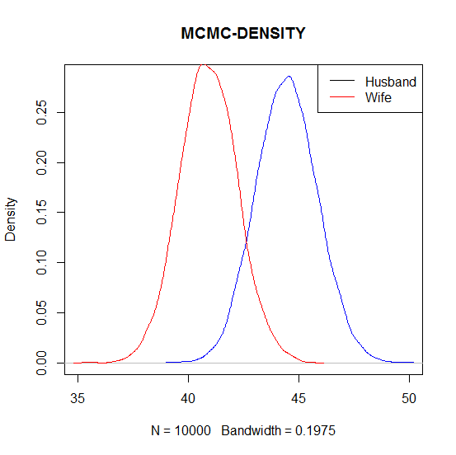

Figure 5: Density Distribution of θh and θw in MCMC simulation

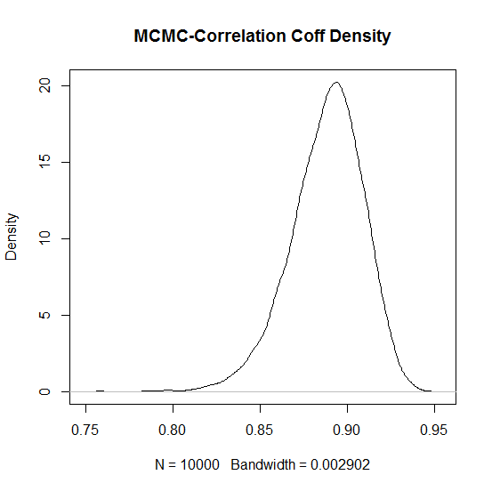

Figure 6: Density Distribution of Correlation Coffecient in MCMC simulation

95% Intervals are:

**Husband θh =(41.81863 47.16969)**

**Wife θw =(38.34298 43.51096).**

**Correlation Coefficient= (0.8421991 0.9240957)**

4. Using the new prior, we can calculate the new distribution. The 95% Interval are:

**Husband θh =(** **41.70611 47.20329)**

**Wife θw =(** **38.36744 43.53102)**

**Correlation Coefficient= (0.7947551 0.8999829)**

**We can see, the actually result under very different prior is actually very close, especially for θh, θw, but correlation coefficient is biased.**

5. The probability that pr(**θh> θw)=1, when using the given data set.**

**Please also refer to the code attached.**

CODE:

###############2##################

library(mvtnorm)

age<-read.table(header = TRUE,"http://www.stat.washington.edu/hoff/Book/Data/hwdata/agehw.dat")

mu0<-c(45,40)

L0<-matrix(c(625,312.5,312.5,625),2,2)

nu0<-4

S0<-matrix(c(625,312.5,312.5,625),2,2)

prior.predictive<-matrix(nrow=100,ncol=2)

for (i in 1:100) {

theta.star<-rmvnorm(100,mu0,L0)

prior.predictive[i,]<-rmvnorm(1,colMeans(theta.star),cov(theta.star))

}

#plot(density(prior.predictive[,1]),col="blue",main="Prior Predictive Distribution",ylim=c(0,0.02))

#lines(density(prior.predictive[,2]),col="red")

#legend("topright", legend=c("Husband","Wife"), col=c(1,2), lty=1)

plot(prior.predictive[, 1], prior.predictive[, 2])

cov(prior.predictive)

abline(v=colMeans(prior.predictive)[1],col='blue')

abline(h=colMeans(prior.predictive)[2],col='red')

legend("topright", legend=c("Husband Avg","Wife Avg"), col=c(1,2), lty=1)

cof=cov(prior.predictive)[1,2]/(sqrt(var(prior.predictive[,1]))*sqrt(var(prior.predictive[,2])))

print(cof)

text(80,20, sprintf("<Correlation Coffecient=\"%f\">",cof))

##############3##################3

n<-dim(age)[1]

ybar<-apply(age,2,mean)

Sigma<-cov(age)

THETA<-SIGMA<-NULL

for (s in 1:10000)

{

Ln<-solve(solve(L0)+n*solve(Sigma))

mun<-Ln%*%(solve(L0)%*%mu0+n*solve(Sigma)%*%ybar)

theta<-rmvnorm(1,mun,Ln)

Sn<-S0+(t(age)-c(theta))%*%t(t(age)-c(theta))

Sigma<-solve(rwish(1,nu0+n,solve(Sn)))

THETA<-rbind(THETA,theta)

SIGMA<-rbind(SIGMA,c(Sigma))

}

plot(density(THETA[,1]),col="blue",main="MCMC-DENSITY",xlim=c(35,50))

lines(density(THETA[,2]),col="red")

legend("topright", legend=c("Husband","Wife"), col=c(1,2), lty=1)

quantile(THETA[,1],c(0.025,0.975))

quantile(THETA[,2],c(0.025,0.975))

####Correlation Coffecient

Coff=SIGMA[,2]/sqrt(SIGMA[,1]*SIGMA[,4])

plot(density(Coff),main="MCMC-Correlation Coff Density")

quantile(Coff,c(0.025,0.975))

###############4####################

library(mvtnorm)

age<-read.table(header = TRUE,"http://www.stat.washington.edu/hoff/Book/Data/hwdata/agehw.dat")

mu0<-c(0,0)

L0<-matrix(c(10^5,0,0,10^5),2,2)

nu0<-3

S0<-matrix(c(1000,0,0,1000),2,2)

n<-dim(age)[1]

ybar<-apply(age,2,mean)

Sigma<-cov(age)

THETA<-SIGMA<-NULL

for (s in 1:10000)

{

Ln<-solve(solve(L0)+n*solve(Sigma))

mun<-Ln%*%(solve(L0)%*%mu0+n*solve(Sigma)%*%ybar)

theta<-rmvnorm(1,mun,Ln)

Sn<-S0+(t(age)-c(theta))%*%t(t(age)-c(theta))

Sigma<-solve(rwish(1,nu0+n,solve(Sn)))

THETA<-rbind(THETA,theta)

SIGMA<-rbind(SIGMA,c(Sigma))

}

plot(density(THETA[,1]),col="blue",main="MCMC-DENSITY",xlim=c(35,50))

lines(density(THETA[,2]),col="red")

legend("topright", legend=c("Husband","Wife"), col=c(1,2), lty=1)

quantile(THETA[,1],c(0.025,0.975))

quantile(THETA[,2],c(0.025,0.975))

####Correlation Coffecient

Coff=SIGMA[,2]/sqrt(SIGMA[,1]*SIGMA[,4])

plot(density(Coff),main="MCMC-Correlation Coff Density")

quantile(Coff,c(0.025,0.975))

#############5############

mean(THETA[,1]>THETA[,2])